**Screenshots of Interactions with ChatGPT**

Prompt 1

Prompt 2

Prompt 3

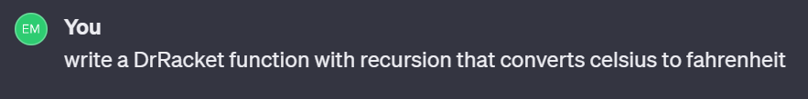

Prompt 4

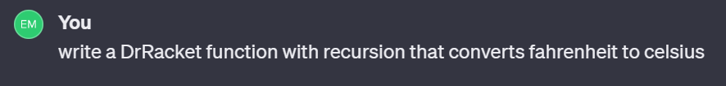

Prompt 5

Prompt 7

Prompt 8

Prompt 9

Prompt 10

